
Game Design and Development for Mobile Devices

Lab 1

Objective:

Gain an understanding about how to develop Java ME games using Netbeans Mobility Pack 6.0 and the Game Builder tool.

Prerequisites:

Netbeans 6 IDE
JDK
MIDP 2.0 / CLDC

Experiment 1:

Open the sample Game Builder project
File > New Project -> Samples -> MIDP -> Simple Game created with Game Builder

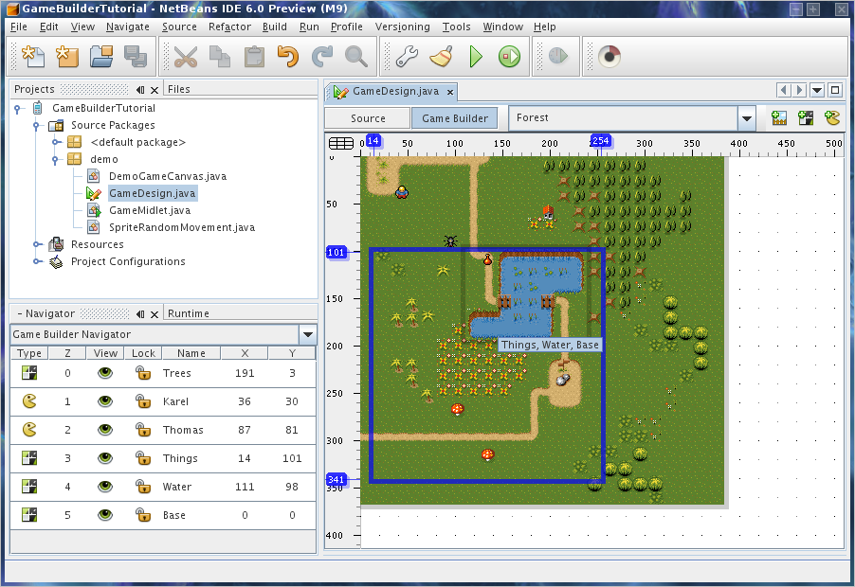

Open that game design and browse through it.
A game design contains several elements – scenes, sprites, and tiled layers.
The current game design contains a forest scene that is made up of 6 layers (4 tiled layers and 2 sprites), this forest scene is a level.

Experiment 2:

Create a new Scene

To add another level, click on the “New Scene” button on the scene editor toolbar (that lies within the GameDesign.java tab.
Name the scene “Desert” and click OK, this will create a new and empty scene with no layers.

Add existing Sprites

Add existing layers by right clicking the inside of the scene editor and adding either a sprite or a tiled layer.
Add the two existing sprites namely “Thomas” and “Karel” to the scene.

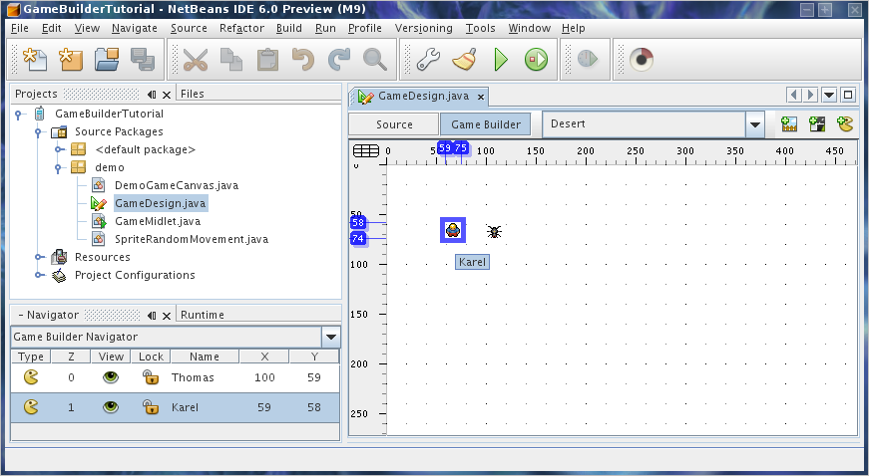

Create a New Tiled Layer

To create a new Tiled Layer click the ‘New Tiled Layer’ button in the scene editor toolbar. In the dialog window name the new tile Sand and select ‘/topviewtiles.png’.
Press OK.

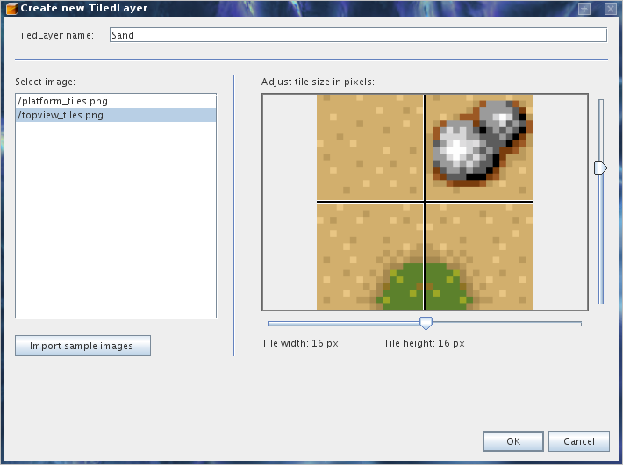

Click the ‘Paint mode’ button from the toolbar and select the ‘sand’ tile you created from the image resource panel. Then drag the mouse across the editor panel to draw the selected tile.
Notice: The editor panel automatically expands if you paint past the edges.
Continue painting with different tiles until you are happy.

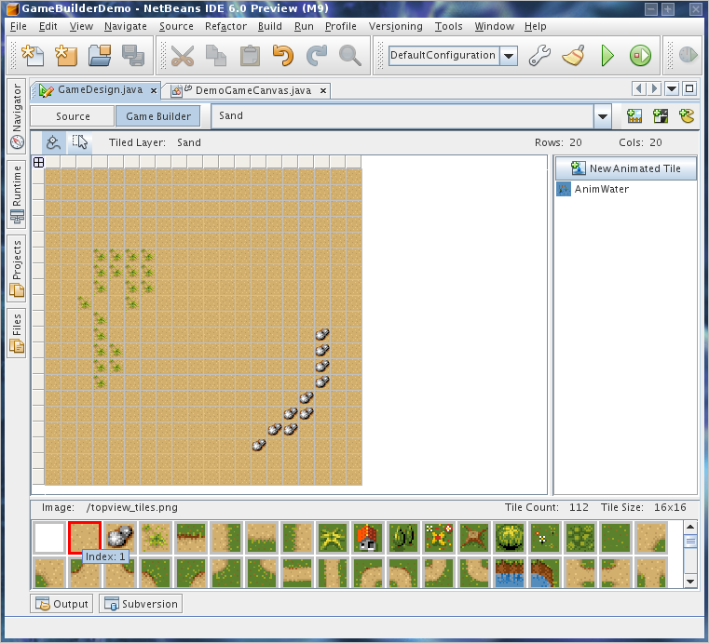

Experiment 3:

Add new tiled layer to the scene

Add the new ‘Sand’ layer that you just created to the ‘Desert’ scene.
To do this, select the ‘Desert’ scene from the combo box in the editor then right click inside the scene editor and select Add Tiled Layer -> Sand.
Drag the tiled layer to X,Y 0,0.
When you do this, the Karel and Thomas sprites will be covered by a cloud, this is because the sprite layers are below the tiled layer in the orders.

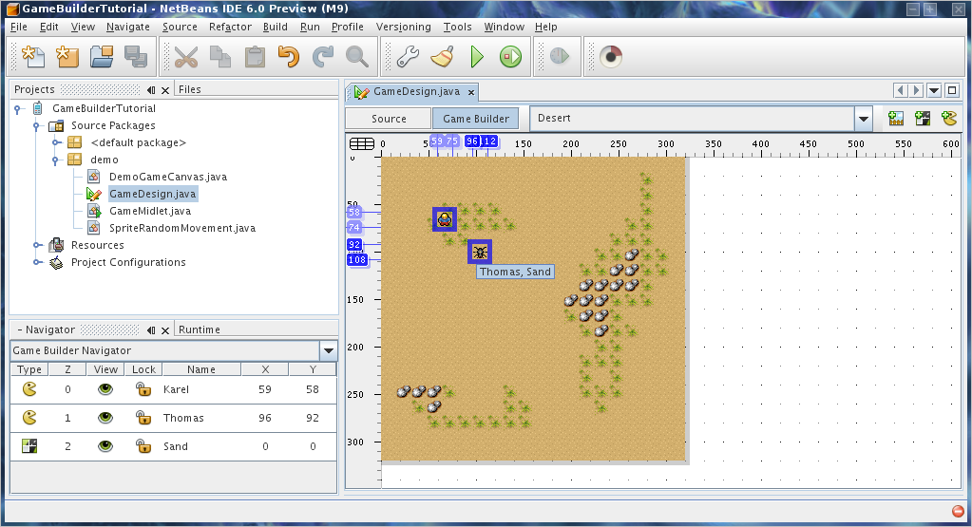

Congratulations you have created a simple game level. To add this level to game play you need to do some coding or download this sample:
http://wiki.netbeans.org/attach/CreatingJavaMEGamesWithGameBuilder/DemoGameCanvas.java
The updated code will switch the game to the 'Desert' level when main sprite 'Karel' walks to the bottom-right corner of the 'Forest' level. The completed game will switch the game to the Desert level once the main sprite Karel walks to the bottom-right corner of the Forest level.

Problem 1:

This does not produce a full game, but the building blocks for a game.
Develop a small game using what you have learned and assembled here.

Additional Files:

http://wiki.netbeans.org/attach/CreatingJavaMEGamesWithGameBuilder/DemoGameCanvas.java
http://wiki.netbeans.org/attach/CreatingJavaMEGamesWithGameBuilder/new_tiled_layer.png
http://wiki.netbeans.org/attach/CreatingJavaMEGamesWithGameBuilder/scene.png
http://wiki.netbeans.org/attach/CreatingJavaMEGamesWithGameBuilder/scene2.png
http://wiki.netbeans.org/attach/CreatingJavaMEGamesWithGameBuilder/scene3.png
http://wiki.netbeans.org/attach/CreatingJavaMEGamesWithGameBuilder/tiled_layer.png

