
Mobile Application Development for
BlackBerry Devices

Assignment 1

Required Software:

Java SE
Java ME (Wireless Tool Kit)
Netbeans (http://www.netbeans.org)
Mobility Pack for Netbeans (http://www.netbeans.org/products/mobility/)

Learning Objectives:

You will gain an understanding of how to develop an application for a mobile device as well as multiple form applications. The subtle differences between Java 2 SE and Java 2 ME will become more prevalent and helpful in later assignments.

Part 1 – Mortgage Calculator:

Your task is to create a Mortgage Calculator in Java ME to be used on mobile devices. The calculator must take in the fields below and produce the customers monthly payments.

Fields you should include are:
Input
- Loan Amount
- Interest Rate
- Loan Term (in years)
* Assume monthly payments.

Output
- Monthly payment value

* HINT: You can check your calculations to match: http://www.mortgagecalculator.org/
(Note: On that site set Property Tax and PMI to 0)

Screenshots:

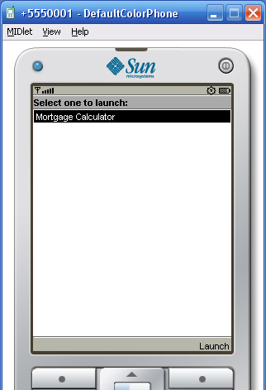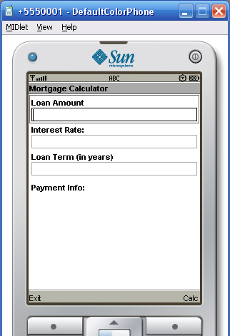

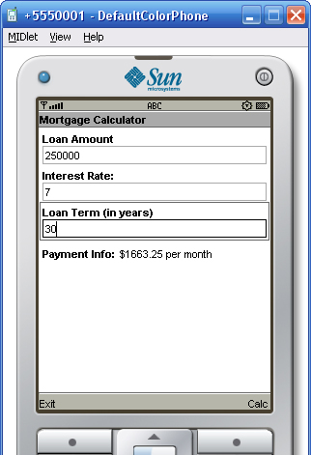
Part 2 - Quiz:

Your job is to develop a simple quiz for a mobile device. The quiz will work as follows:
Once logged in successfully and the J2ME Quiz is selected, the user is presented with a list of multiple choice questions (five would be fine for this quiz). The user reads each question and selects a possible answer. Once the user submits the quiz, it will be marked (on the client-side) and the user will be presented with a score. If the score is not perfect the user should be presented with the questions s/he got wrong and the right answer(s) for those questions.

Note:
- The application should have sufficient buttons to navigate between the screens.
- You could display all questions (and their multiple answers) on the same screen where the user needs to scroll down to see all questions, or one question per screen (your choice).

Screen shots:



